✅ Day 10 Practical Lab
1️⃣ Check Your Network Interface
Run:
ip a
Find:
- Interface name → enp0s3
- Your IP address
Example:
inet 192.168.1.93/24
Write this in notes.

2️⃣ Check Default Gateway
Run:
ip route
Example output:
default via 192.168.1.1 dev enp0s3
Meaning:
Item | Meaning
default | route to internet
192.168.1.1 | router / gateway
enp0s3 | interface
Write in notes:
Default Gateway = 192.168.1.1

3️⃣ Analyze Packet Flow
When you run:
ping google.com
The packet flow is:
VM
↓
Default Gateway (Router)
↓
ISP Network
↓
Internet Backbone
↓
Google Server
Write this exactly in your notes.

4️⃣ Run Traceroute
Run:
traceroute google.com
Example:
1 192.168.1.1
2 ISP network
3 ISP backbone
4 Internet backbone
5 Google server
Understand:
Hop | Meaning
1 | Your router
2 | ISP
3+ | Internet
Your screenshot already shows this correctly.

5️⃣ Install SSH (if not installed)
Check:
rpm -qa | grep openssh-server
If missing install:
sudo dnf install openssh-server -y

6️⃣ Start SSH Server
Run:
sudo systemctl start sshd
Enable at boot:
sudo systemctl enable sshd
Check status:
systemctl status sshd
Expected:
active (running)

7️⃣ Verify SSH Port
Run:
ss -tulnp
Look for:
tcp LISTEN 0 128 0.0.0.0:22
Meaning:
Field | Meaning
tcp | protocol
LISTEN | service waiting
22 | SSH port

8️⃣ Ping Second VM
From VM1
ping VM2_IP
Example:
ping 192.168.56.102
Expected:
64 bytes from 192.168.56.102

9️⃣ SSH Into VM2
Run:
ssh username@VM2_IP
Example:
ssh aditya@192.168.56.102
If successful:
aditya@server:~$
You are now logged into the second VM.

📄 What Your Notes Should Contain (Day 10)
Write these:
Packet Flow
VM → Gateway → ISP → Internet → Server
Important Commands
ip a
ip route
traceroute
ssh
ss -tulnp
SSH Port
22
Default Gateway Meaning
Router that sends traffic outside local network.

✅ Day 10 Expected Output
You should have:
✔ traceroute analyzed
✔ packet flow written
✔ SSH running
✔ SSH port verified
✔ connectivity between VMs
1️⃣ Check Your Network Interface
2️⃣ Check Default Gateway
3️⃣ Analyze Packet Flow
4️⃣ Run Traceroute
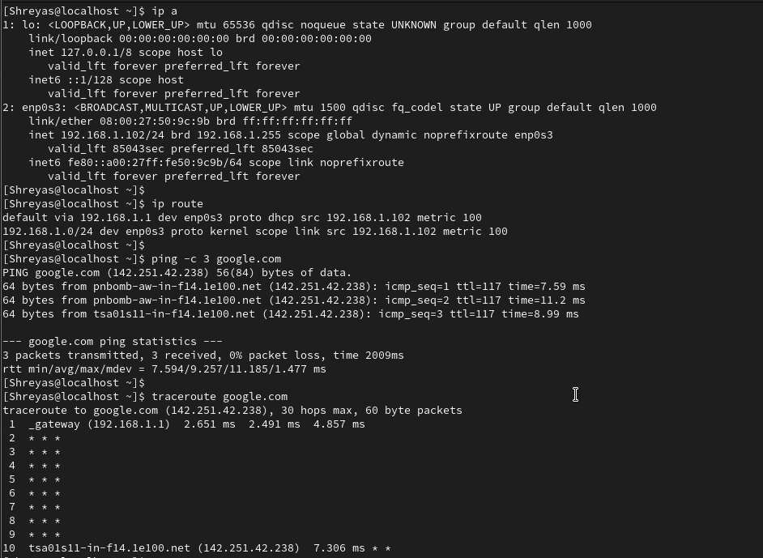

5️⃣ Install SSH (if not installed)
6️⃣ Start SSH Server
7️⃣ Verify SSH Port
8️⃣ Ping Second VM
8️⃣ Ping Second VM

